Automate the Boring Stuff with Python Programming

* Chapter - 1
* Expression Evaluation

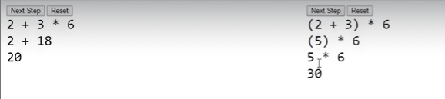

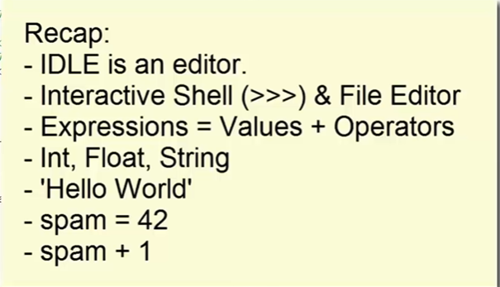

* Chapter – 2
* Output of the program written

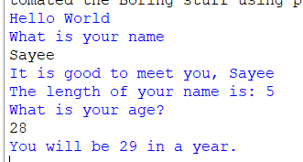

* Values which are passed through functions are known as ‘Arguments’
* Print, input, len, is a 🡪 Built in function.
* 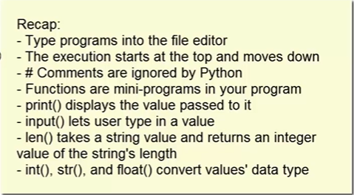
* Chapter - 3